**Description:**

Two mysterious spirits of unknown origin found by Hiroto. They are separate spirits but act as one. Spirits that do not get attacked by Predators.

Secret Backstory:

The two comrades of the Sole Existence when they were alive. Their band of three encountered a tragic fate in the hands of human trafficking and both died in an attempt to escape their clutches. Thrown into the same dump, the two’s bodies were revived using the remaining power of the dying god, Hades, at the request of the Sole Existence. This marked the death of the former human and the rebirth of the Sole Existence.

Yin – Former Sorun

Yang – Former Ghoul (Living)

<https://www.pixiv.net/en/artworks/110529902> 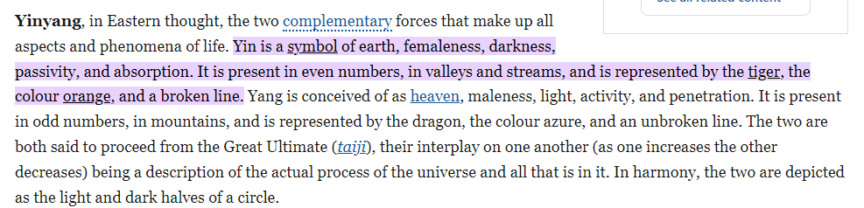

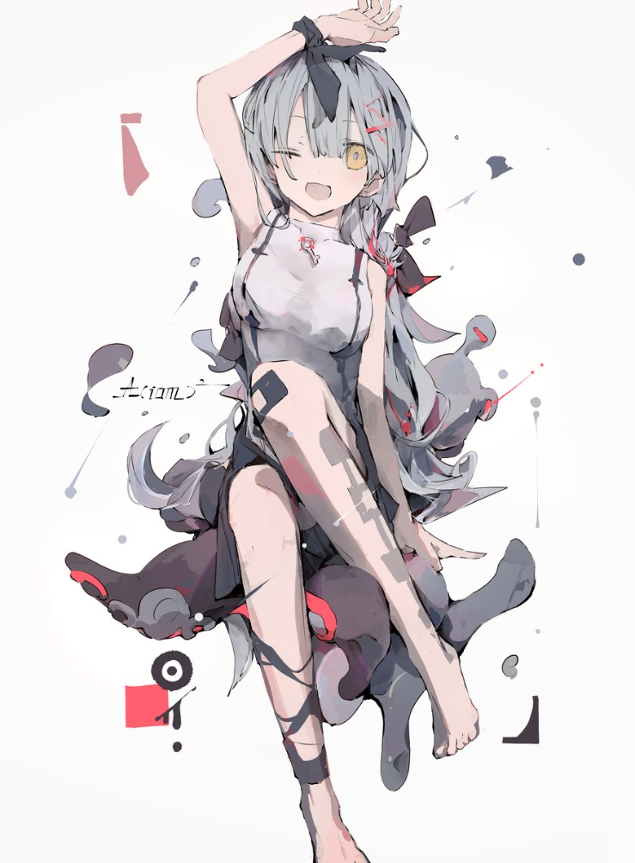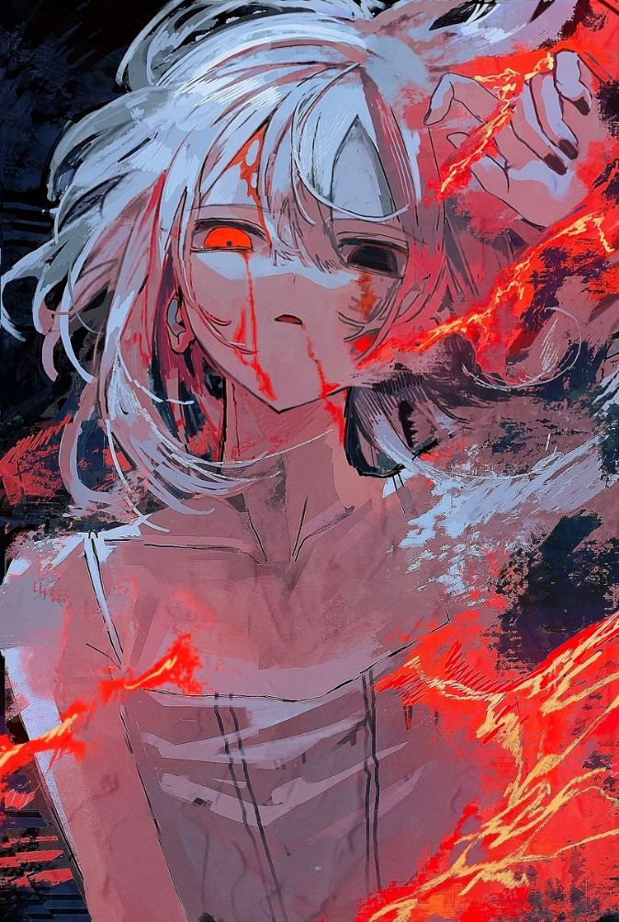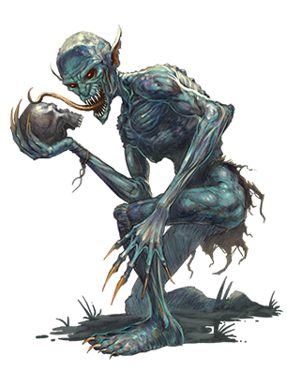 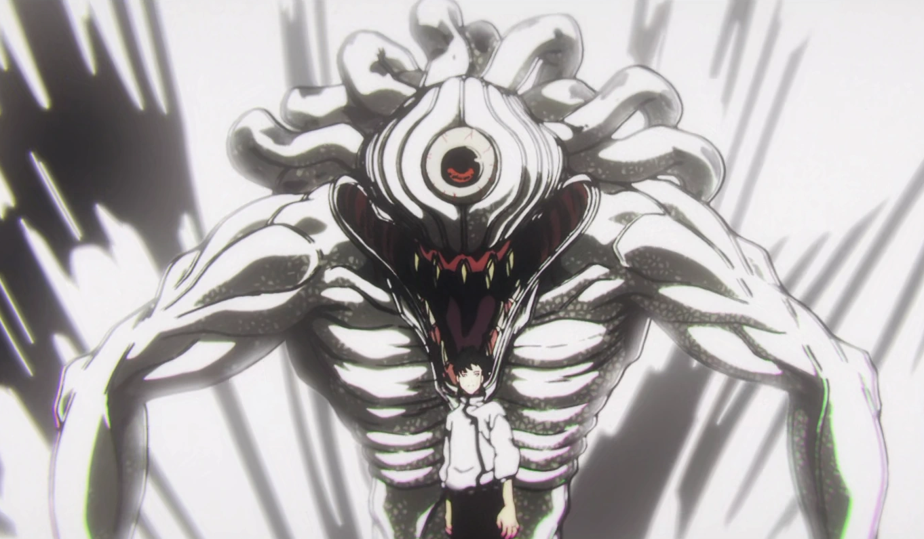

**Soul:**

**Abilities:**

Mental Arts

Yin – Control Type (Direct Target user)

Weakening, Silence, Blindness, Slow, Confusion, Binding, etc.

Yang – Attack Type (Spirit Field user)

Heavily suggests wills, vomit, stop breathing, not speaking, etc.

**Weapons:**

Yin – Black Ribbons

Yang – Tongue

**Physical Details:**

Age A

Gender A

Race/Heritage A

Height A

Weight A

Body Posture and Bearing A

Distinguishing Marks A

Physical Challenges A

Overall Condition and Presentation A

Clothing Style Preferences A

Common Adornments A

**Daily Life:**

*Family and General Life*

A

*Talents and Skills*

A

*Occupation*

A

*Hobbies*

A

**Backstory:**

<Summary>

*Wound*

A

*Fear*

A

Because of these:

*Lie*

A

*Secrets*

A

**Personality:**

*Positive Traits*

Influencers/Role Models

A

Past Achievements and Sources of Pride

A

Ethics and Values

A

Environmental Contributions

A

Traits

A

*Negative Traits*

Bad Influencers/Role Models

A

Unjust/Unfair Experiences

A

Painful Memories

A

Negative Life Lessons

A

Traits

A

**Behavior:**

*Core Behavior*

A

*Emotional Range*

Idle: A

Stressed: A

Exhausted: A

Inebriated: A

Overstimulated: A

Anxious: A

Distracted: A

Bored: A

Attraction: A

Aroused: A

X

X

X

X

X

*Negative Coping Mechanisms*

A

*Positive Coping Mechanisms*

A

*Uncomfortable Emotions*

A

*Quirks*

A

**Motivations:**

*Outer Motivation*

A

*Inner Motivation*

A

*Emotional Shielding*

A

*Fatal Flaw*

A